Software Requirements Specification
For
Mess Management Service
(Manage all mess works of a mess manager)
Version 1.0 approved
Prepared by:
1.Shreshthajit Das(2017831013)
2.Fahim Tajwar Saikat(2017831020)
3.Abdullah-Al-Foysal(2017831032)

Date :10/4/2019

Submitted to:
Sayma Sultana Chowdhury
Assistant Professor,IICT,SUST

Date :30/4/2019
Table of Contents
Table of Contents ii
Revision History ii
1. Introduction 1
1.1 Purpose 1
1.2 Document Conventions 1
1.3 Intended Audience and Reading Suggestions 1
1.4 Product Scope 1
1.5 References 1
2. Overall Description 2
2.1 Product Perspective 2
2.2 Product Functions 2
2.3 User Classes and Characteristics 2
2.4 Operating Environment 2
2.5 Design and Implementation Constraints 2
2.6 User Documentation 2
2.7 Assumptions and Dependencies 3
3. External Interface Requirements 3
3.1 User Interfaces 3
3.2 Hardware Interfaces 3
3.3 Software Interfaces 3
3.4 Communications Interfaces 3
4. System Features 4
4.1 System Feature 1 4
4.2 System Feature 2 (and so on) 4
5. Other Nonfunctional Requirements 4
5.1 Performance Requirements 4
5.2 Safety Requirements 5
5.3 Security Requirements 5
5.4 Software Quality Attributes 5
5.5 Business Rules 5
6. Other Requirements 5
Appendix A: Glossary 5
Appendix B: Analysis Models 5
Appendix C: To Be Determined List 6

Revision History
Name | Date | Reason For Changes | Version
First Version | 11.03.19 | Initialize | 1.0

Introduction

Purpose
According to Mess Management ,This System will provide those Services, which users need immediately and co-Operate with all Member of a Mess.
Mess Management System will improve all Activities of a Mess those will be shown on product scope .
Our survey of what people want from us for a mess management system shown below:
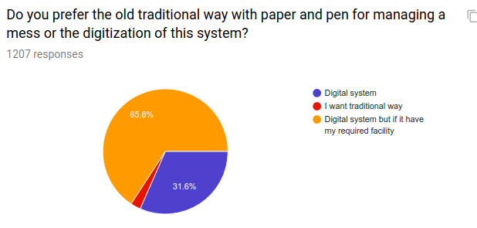
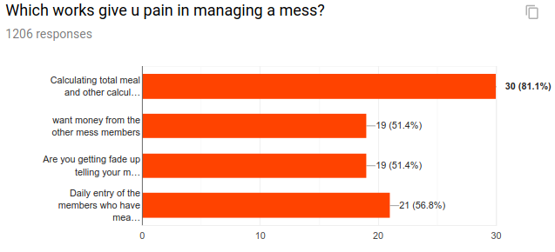

Document Conventions
- MMS : Mess Management Service
- Super Admin: Mess Manager(Service maintainer)
- Member: Mess Member

Following are some of the important terms used throughout this
document:
- Daily meal update
- Add extra cost
- Inform to Bazar (time)
- Online Bazar now with Home delivery
- Add extra cost and deposite calculation
- Money Borrow from mess member
-  Activity Diagram: It captures the sequential actions that occur within a business process or within a use case.

Intended Audience and Reading Suggestions

This is a prototype for an online based system that will serve all needed information about MESS Member & Activities of Mess . Some recommended topic for readers:
● Developers: Product feature, User characteristics,
Operating environment, System features.
● Designers: Project scope, User characteristics, System
features, External interface requirements.
● Domain: Product perspective, Product features, User
characteristics, System features,
● Public/User: Project scope, Product features, System features.

Product Scope

Mess Management Service(MMS) has following scope:
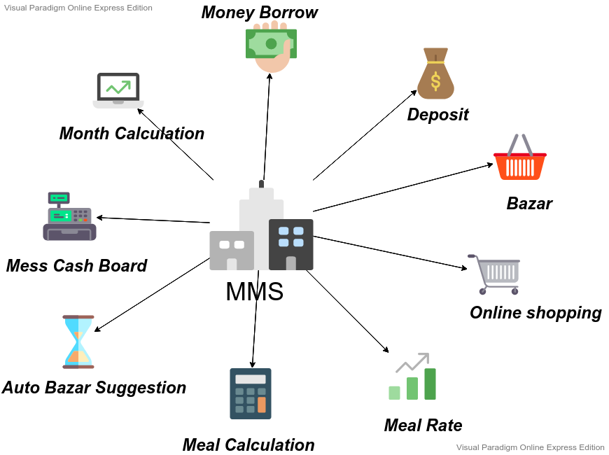

References
1.”Meal Manager” on Android Play Store.
2. “Meal Expense”

Overall Description

Product Perspective
- Create Mess Account:
- Activities:
- Daily meal update:
- Add extra cost :
- Inform to Bazar (time)
- Online shopping
- Calculation
- Add & Delete member
- Communication through notification

Product Functions
- Daily Meal:
The members of the mess can book for meal daily before the bazar. They have option for auto meal book or cancellation any meal from this option.Previous meal count can’t update which has the only authentication to Mess Manager.
- Add extra cost:
The members of the mess can add extra cost except meal with the permission of the mess manager. For example if we buy a handwash for the mess it will obviously not go in the section of meal. Any members of the mess can add the cost of purchasing handwash to the extra cost section. Users have a short note section so that they can recall which item they had bought in future.
- Auto Bazar Suggestions:
In this section the user can get the suggestion for bazar. In this section there will be a section of recipe . There will be a huge collection of famous recipe. As our users are not master at cooking , we will provide the ingredients of that recipe. And that member , who have to bazar will not face any dilemma for bazar.
Manual suggestion edition is only applicable for Mess Manager.

- Online Shopping:
In this section our users will be able to contract with online shopping services such as SWAPNO ,FOOD PANDA ,HELLO DELIVERY etc.
Global flatform such as Daraz,Amazon will also included in this section.

- Add Bazar Cost: Any member can add bazar cost which is belongs to Meal.
Irrevant cost will add to Add extra cost.
Only Mess Manager can update any information with will notify to all Members.
- Borrow Money:
Any member of a mess can borrow money from each other which will be noted with date and time and money lander confirmation.
- Deposit Money:
This section is only for Mess Manager or super admin.After getting money from any member, super admin will add Deposit Money.

- Mess Cash Board: Current Deposit ,cost,Meal Rate will auto update here.

- My Calculation: Meal Rate, Deposite money,need to pay .

User Classes and Characteristics
- Users: who are able to use Smart phone or Personal Computer .
- Users Education Level:A Good command in English.
- Frequent User: Student community, A group of People with Different Jobs.

Operating Environment
- Touch screen for convenience
- keypad (on screen and keyboard)
- Will run the Latest version of Application
- Ability to connect to web server or network
- Ability to take input from user(mess member)

Design and Implementation Constraints
Sign Up:

- Email or phone Number

Login:
Valid user:
- Email Varification with OTP(one time password) to phone

User Documentation
See product scope & product function..

Assumptions and Dependencies
- System Failure or crash
- Hardware fails to load
- Always Connect to internet or web server.
- Unlimited Notification

External Interface Requirements

User Interfaces
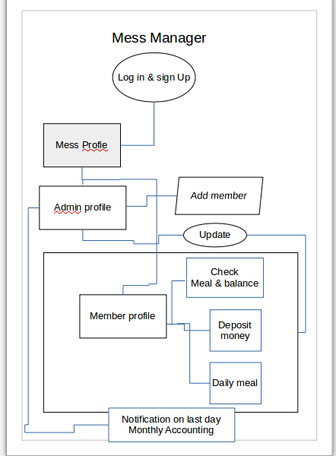

Hardware Interfaces

Operating system | Windows: Windows XP SP3, Windows Vista SP2, Windows 7,Linux,Mac
CPU | Pentium processor at 90 MHz or higher
Memory | 2 GB RAM
Hard drive | 50 MB available in the hard disk
Media | 2x or higher
Graphics hardware | DirectX 3.0 or higher

Software Interfaces
Mess Management Service software interface:
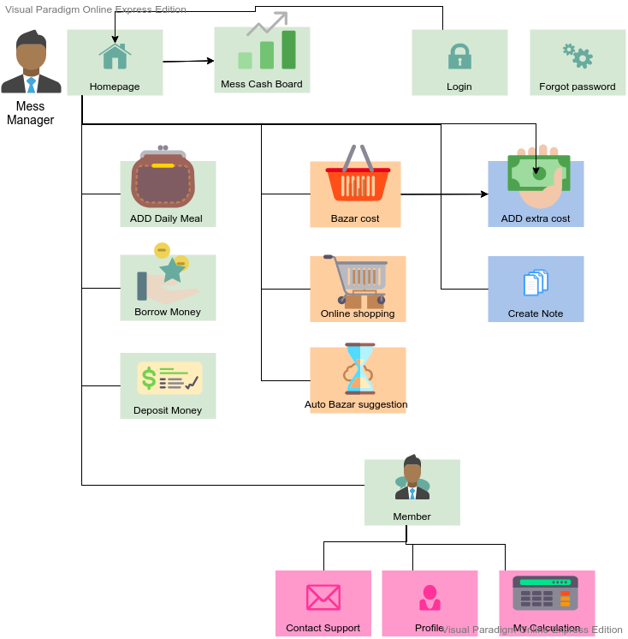

Communications Interfaces

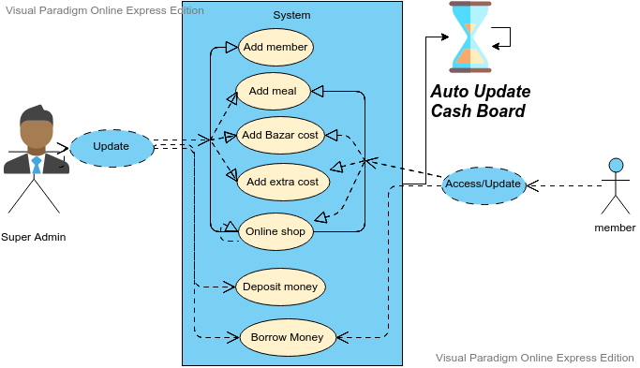
Connecting to Mess Management service:

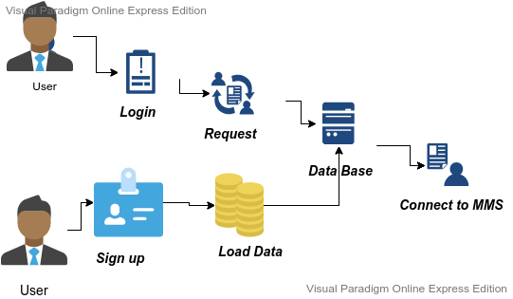

Communication interface

System Features

System Feature 1
Mess Cash board
4.1.1 Description and Priority:
Here Mess Cash board updates automatically after user input. It is an overview of total collected money and spend money.
4.1.2 Stimulus/Response Sequences:
Users have to add data of bazar and meal manually and these response will be used to calculate the mess cash board
4.1.3 Functional Requirements

REQ-1: A simple Database
REQ-2: Network connectivity

System Feature 2
Auto Bazar Suggestions
4.2.1 Description and Priority:
In this section the user can get the suggestion for bazar. In this section there will be a section of recipe . There will be a huge collection of famous recipe. As our users are not master at cooking , we will provide the ingredients of that recipe. And that member , who have to bazar will not face any dilemma for bazar.
4.2.2 Stimulus/Response Sequences:
We will get data of Bazar items from a particular place and if the bazar of the mess will not contain those items we can suggest that items
4.2.3 Functional Requirements

REQ-1: A huge collection of food recipe
REQ-2: AI Algorithm
REQ-3: A huge collection of other users data

Other Nonfunctional Requirements

Performance Requirements

5.1 Safety Requirements

I.Overview:
This term will show the main functionality of this software.
II.Specification:
Here the specified requirements for this software must be specified.Clear,precise,unequivocal,verifiable,maintainable,testable,commensurate with the safety integrity level.
III.Desighn and development:
Equipment ,capacity and operator time interface with response time performance.
Iv.validation:
Here the validation process includes:
->>>Gatthering and analysis of the specifications and requirements.
->>>Based on specificGations and requirements, preparation of test strategies,plans and cases, that seems fit for use.
->>>Go for testing the boundary values along with stress and functionalities test.
->>>Test the error message.
->>>Conducts software evaluation, as it ensures that the software meets the all pre-decided requirements and is acceptable for use.

Security Requirements
I.Log in:
This option is a must for user for opening a acount for using this app;
II.Email including:
For every member of the mess an account should be opened.
III.password or pin number:
Apassword or pin number will need to add here for every member to safe secure for his acoount.
IV.Email verification code:Email verification code will need to verify when opening a new account.
v.Mobile number:
The mobile number of every mess member will help him for sending the email verificaton code.

Software Quality Attributes
.
Reliability: Reliability of a software system derives from
- Correctness
- Availability
The behavior over time for the fulfillment of a given specification depends on the reliability of the software system.
Adequacy: Factors for the requirement of Adequacy:
- The input required of the user should be limited to only what is necessary. The software system should expect information only if it is necessary.
- The results produced by the software system: The results that a software system delivers should be output in a clear and wellstructured form and be easy to interpret.
Learnability: Learnability of a software system depends on:
- The design of user interfaces
- The clarity and the simplicity of the user instructions (tutorial or user manual).
Robustness: Robustness reduces the impact of operational mistakes, erroneous input data, and hardware errors.

Business Rules
A business rule typically consists of the following information, in the order specified:
- Definitions:At the beginning of the rule, we have to set parameters that identify business terms by using easy to understand names.
- Conditions:The conditions section of the rule contains the “if” statements.
These statements define the conditions under which actions are completed.

